Infinite Bus

**Definition**: The bus whose voltage and frequency remain constant even after the variation in the load is known as the infinite bus. The alternators operating in parallel in a power system are the example of the infinite bus. The **on** and **off** of any of the alternators will not affect the working of the power system.

The capacity of a parallel operating system is enormous, their voltage and frequency remain constant even after the disturbance of the load. The connection and disconnection of any of the machines will not affect the magnitude and phase of voltage and frequency of an infinite bus. In an infinite bus system

* The voltage and frequency always remain constant.
* The synchronous impedance of the bus is low because of the parallel operations of the machine.

## Synchronous machine on Infinite Bus

The performance of the synchronous machine varies on the infinite bus. When the synchronous machine operates independently,  variation in their excitation causes the changes in their terminal voltage. The power factor of the synchronous machine depends only on their load. But when the synchronous machines are operating in parallel, the change in their excitation changes the power factor of the load.

**Obtaining an Infinite Bus**

Consider generators G1, G2, G3……Gn connected to an infinite bus as shown in the figure below:

[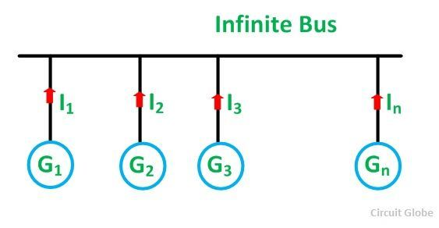](https://circuitglobe.com/wp-content/uploads/2016/01/INFINITE-BUS-FIG-compressor.jpg)

**Proof of Voltage Remaining Constant**

Let,

* V be the terminal voltage of the bus,
* E be the induced emf of each generator,
* ZS is the synchronous impedance of each generator,
* n is the number of generators in parallel

[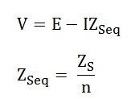](https://circuitglobe.com/wp-content/uploads/2016/01/infinite-bus-eq-1-compressor.jpg)When n is very large ZSeq→ 0 and, therefore, I ZSeq→ 0

Therefore, V = E (constant)

If the number of alternators operating in parallel is infinite only then ZS = 0

**Proof of Frequency Remaining Constant**

Let, J be the moment of inertia of each alternator

The total moment of inertia of all n alternators is given as:[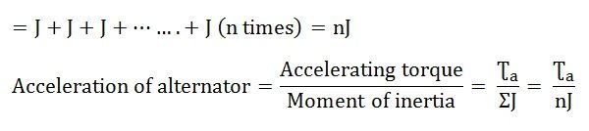](https://circuitglobe.com/wp-content/uploads/2016/01/infinite-bus-eq-2-compressor.jpg)If the value of n is very large, nJ is also very large.

Therefore, acceleration → 0, and the speed is constant.

The above equation shows that the constant voltage and frequency of the bus depend on the number of machines operating parallel.

### What is Power?

The diverse power terms in electrical power systems include active, reactive, and apparent power, all of which lead to the introduction of ‘power factor’ effectiveness in an AC circuit. [AC circuits transfer energy](https://control.com/technical-articles/voltages-of-devices-in-ac-circuits/) to resistive and reactive loads and, in the case of purely resistive loads, the energy is dissipated in the same way direct current dissipates energy in a resistor.

Electric power is the rate at which energy is transferred to or from a part of an electric circuit. In an electrical circuit, the power is equal to the voltage difference across the element times current V×I. The power is measured in watts 1W=1J/s

Electric Power=Voltage×Current

P=V×I

P=I2×R

P=V2R

These equations are derived from Ohm’s law which is V=I×R where V = Voltage or potential difference in the circuit, [I = current](https://control.com/technical-articles/How-to-Measure-AC-Current-Using-a-Clamp-Meter/), and R = Resistance in the circui

#### There are Three Types of Loads

1. Resistive Load: where V and I are in phase and the power is always positive like braking resistors, heaters, and light bulbs.

2. Inductive load: current lags by voltage like [motors](https://control.com/technical-articles/dc-motors-why-are-we-still-using-them/), fans, and transformers.

3. Capacitive load: current leads by voltage (few examples of pure capacitive loads).

The phase-angle difference between the current and voltage has an important effect on the power supplied, as the instantaneous voltage corresponding to any particular instantaneous current depends on the angle between them. Therefore, in the alternating current circuits power cannot usually be obtained simply by multiplying the effective voltages and effective amperes as was done in the case of DC. The effect on the power of the difference in phase angle between the current and voltage must be taken into account.

### Active Power or Real Power

Active power is often called real, actual, true, or useful power. In DC circuits, power is simply the voltage across the load times current flowing through it because in DC circuits there is no phase angle between the voltage and current therefore no power factor in DC circuits. In other words, the voltage and current are in phase with each other, meaning the voltage and current start at the same time, reach a peak, and then again touch zero at the same time.

P=V×I for DC circuits

Whereas in AC circuits, there is a phase angle between voltage and current expressed with the added component of cosθ.

In a single-phase AC circuit active power is:

P=V×I×cosθ

In a [3-phase AC circuit](https://control.com/technical-articles/understanding-industrial-three-phase-voltage-systems/):

P=3×V×I×cosθ

In Figure 3, the current and voltage are in phase with each other making a +90 degree angle at the same time and the positive voltage times positive current generates positive power. When both current and voltage are negative, the power is still positive therefore in both cases the power is always positive this is called active power. The power curve will lie entirely above the horizontal axis and reflects that all of the work done is positive.

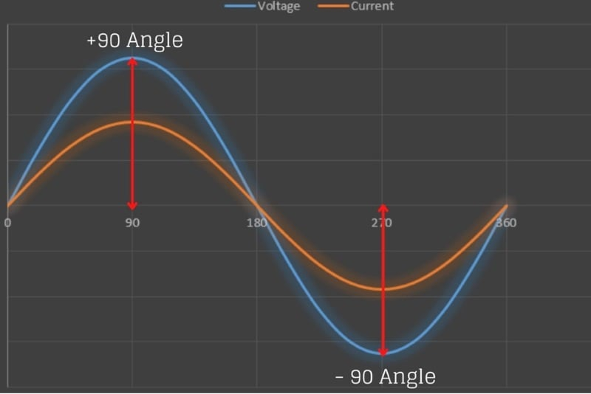

##### Figure 3. Current and voltage are in phase with each other

The real power (also called useful power or watt-full power) actually does the real work in the circuit and always flows from source to load or is supplied to the load from the generator all of the time as in Figure 4.

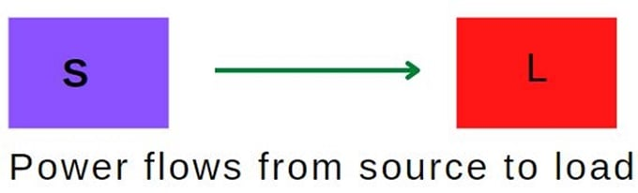

##### Figure 4. Active power flows from source to load

#### Features of Active Power:

* The active power is always positive and does not change its direction, always flows from source to load.
* Denoted by P and [measured in watts (kW, MW, GW)](https://control.com/technical-articles/mathematical-units-for-electrical-troubleshooting-and-control-operations/).
* Measure using a wattmeter.
* Active power produces heat, mechanical power, and light.

### Reactive Power

Reactive power occurs in AC circuits when voltage and current are not in phase. Its unit is VAR (voltage ampere reactive). In the real world, loads are a combination of resistive, inductive, and capacitive elements and it is impossible to determine the nature of the load (small/large, domestic/industrial inductive/capacitive). There are two types of reactance:

* Capacitive Reactance (negative)
* Inductive Reactance (positive)

The power can be positive and negative. When the power is flowing from source to load then it's positive, and the power is flowing from load to source then it’s called negative power. In general, reactive power is only defined for AC circuits and continuously bounces back and forth between source and load and is symbolized with the letter Q as in Figure 5.

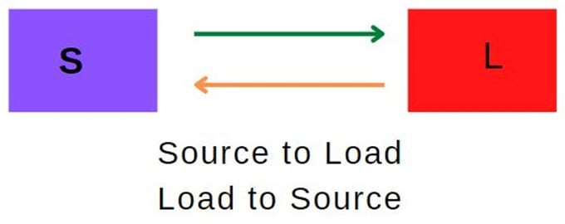

##### Figure 5. Reactive power flows from source to load and back to the source

Reactive Power (Q)

Q=V×I×sinθ

#### Features of Reactive Power:

* Changes its direction periodically and it is positive and as well as negative.
* Donated by letter “Q” and measured in VAR, KVAR, MVAR
* Measured using VAR meter.
* [Transformers](https://control.com/technical-articles/grounding-for-control-transformers/) and induction motors use reactive power to produce a magnetic field.

Transformers also need reactive power to generate a magnetic field in the primary coil and induce a voltage in the secondary coil. Therefore, if the reactive power supply is not adequate, the transformer will not transform voltages and the motor will not rotate. The synchronous alternators also generate or absorb reactive power depending upon DC excitation to its field winding. When the generator is over-excited it generates the reactive power and absorbs reactive power when the generator is under-excited.